**HOME AUTOMATION USING – IoT (Based on Smoke and Gas Detection System)**

**Working Principle:**

1. **Sensors Used**: This system uses sensors like **MQ-2** or **MQ-5**, which can detect **smoke**, **LPG**, **methane**, or **carbon monoxide (CO)**.
2. **Triggering Condition**: When the **concentration of gas exceeds safe levels**, the sensor activates the response system.
3. **System Response Includes**:
   * **Alarm Triggered**: A sound alarm alerts nearby people.
   * **Automatic Actions**: The system can automatically:
     + **Open windows** for ventilation.
     + **Turn off gas valves** to prevent explosions or fire.
   * **Notification Sent**: Alert is sent to:
     + **User's smartphone**.
     + **Emergency services** (fire brigade/gas company), if necessary.

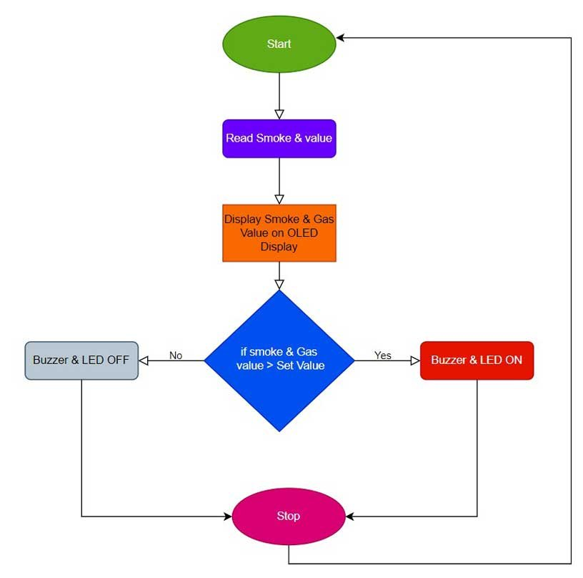**DIAGRAM:**

**IoT Role in Smoke & Gas Detection:**

1. **Live Monitoring**:
   * Continuously monitors **air quality data**.
   * Displays real-time data in a **mobile app** or dashboard.
2. **Automated Response**:
   * IoT system acts instantly without waiting for human command.
   * Helps in taking quick decisions (e.g., turning off gas, opening fans).
3. **Data Logging**:
   * Maintains **history logs** of gas/smoke readings.
   * Useful for **analysis**, **predictive maintenance**, and **future safety improvements**.

**IoT-Based Home Automation System**

**What is Home Automation?**

* It’s the **use of smart devices and IoT technology** to manage and control **lighting**, **security**, **appliances**, and **climate**.
* Systems can **monitor, make decisions**, and **act without human involvement**.

**Role of IoT in Home Automation:**

* Enables devices to:
  + **Connect** to each other (via network).
  + **Communicate** via protocols like Wi-Fi or Zigbee.
  + **Act intelligently** based on data (like detecting smoke or movement).

**Key Components of IoT-Based Detection System**

**1. Sensors (Input Devices):**

* **Motion Sensors**: Detect human movement (for intruder alerts).
* **Magnetic Door/Window Sensors**: Detect if doors/windows open.
* **Smoke Detectors**: Detect presence of smoke or fire particles.
* **Gas Sensors**: Sense hazardous gases like LPG, methane.

**2. Controllers:**

* **Microcontrollers** like **Arduino** or **Raspberry Pi**.
* They **collect data** from sensors and **execute logic** (e.g., if gas detected, trigger fan + alarm).

**3. Actuators (Output Devices):**

* Devices that **perform physical actions**:
  + **Sirens** for audio alarms.
  + **Exhaust fans** to push out harmful gases.
  + **Lights** to warn people or illuminate escape paths.

**4. Communication Protocols:**

* Used to **transmit data** from sensors to the cloud/server or smartphone.
* Examples: **Wi-Fi**, **Zigbee**, **Bluetooth**.

**5. Cloud/Server:**

* Stores all data.
* Processes sensor readings.
* Sends alerts and performs advanced computations (like comparing thresholds).

**6. User Interface:**

* **Mobile Apps** or **Web Dashboards** for:
  + Viewing sensor data.
  + Setting thresholds.
  + Receiving alerts and controlling devices remotely.

**IoT-Based Intrusion Detection System**

**Working:**

1. **PIR Sensors**:
   * Detect motion **inside or near** the house.
   * Ideal for sensing unauthorized activity.
2. **Door/Window Sensors**:
   * Detect if doors/windows are **opened unexpectedly**.

**Armed Mode Functionality**:

* + If motion is detected when system is **"armed"**:
    - An **alarm is triggered**.
    - **Notification sent** to user’s mobile.
    - **Security camera** (if connected) records and sends **live video**.

**IoT Role in Intrusion Detection:**

1. **Real-Time Alerts**:
   * Alerts are sent via **Wi-Fi** or **GSM** networks.
2. **Remote Access**:
   * User can view camera feed, disable alarm, or lock doors from **anywhere**.
3. **AI Integration**:
   * Uses **AI for smart decision-making**, e.g.:
     + **Face recognition** to identify known persons.
     + **False alarm reduction** (ignoring pets or minor motion).

**DEVELOPMENT OF IOT APPLICATION**

## ****What is IoT (Internet of Things)?****

The **Internet of Things (IoT)** means connecting everyday **physical devices** (called "things") to the **internet** so they can **collect**, **send**, and **receive data**.

These devices are equipped with:

* **Sensors**: to detect and measure data (like temperature, motion, etc.)
* **Software**: to process and analyze the data
* **Technology**: to connect and communicate with other devices

**Example**: A smart air conditioner can sense the room temperature and adjust cooling automatically based on your preferences.

## ****Main Elements Required for Any IoT Application****

### ****Cloud Technology****

* + Think of it as **online storage and brain** of your IoT system.
  + It **stores data** collected by devices.
  + It helps **analyze the data** and **control devices** remotely.

🔍 Example: A smart bulb can be turned on/off from your phone using cloud services.

### ****Hardware****

* + The **physical parts** of the system.
  + Includes:
    - **Sensors** – to collect data (e.g., temperature, humidity)
    - **Actuators** – to perform actions (e.g., turn on a motor)

🔍 Example: A sensor detects motion, and the actuator turns on a light.

### ****Network****

* + Helps devices **talk to each other** and the cloud.
  + Uses **Wi-Fi**, **Bluetooth**, **Zigbee**, or **5G** to send/receive data.

🔍 Example: Your smartwatch uses Bluetooth to send data to your phone.

### ****Software****

* + The **program or application** that:
    - **Processes the data**
    - **Visualizes information** (like on your screen)
    - Makes decisions or sends alerts

🔍 Example: A fitness app shows your step count and alerts you when to move.

## ****Steps to Develop an IoT Application****

### ****Define the Requirements****

* + First, be clear about:
    - What is the **purpose** of the app?
    - What should it **do**?
    - What are the **goals**?

🔍 Example: "I want to build a smart farming system to monitor soil moisture and turn on water when needed."

### ****Choose the Right Hardware****

* + Pick the right:
    - **Sensors** (e.g., temperature, moisture)
    - **Actuators** (e.g., pumps, fans)
    - **Controllers** (e.g., Arduino, Raspberry Pi)

🔍 Example: Use a soil moisture sensor and a water pump for smart irrigation.

### ****Select the Right Connectivity Protocol****

* + Choose how the devices will connect:
    - Wi-Fi (home/office)
    - Bluetooth (short range)
    - Zigbee (low-power)
    - 5G (fast, for large-scale systems)

🔍 Example: A home security system might use Wi-Fi for fast alerts.

### ****Ensure the Firmware is Well Equipped****

* + Firmware is the software **inside** the hardware.
  + Make sure it is:
    - **Efficient** (works well)
    - **Secure** (safe from hackers)
    - **Updateable** (can be improved later)

🔍 Example: Code on an Arduino that reads temperature and sends it to the cloud.

### ****Select the Right Cloud Platform****

* + Choose a cloud service to store and analyze your data:
    - **AWS (Amazon Web Services)**
    - **Azure (Microsoft)**
    - **Google Cloud**

Look for:

* + **Data storage** capacity
  + **Analytics tools**
  + **Scalability** (can grow with your needs)

🔍 Example: Store sensor data on Google Cloud and show it on a dashboard.

## ****Summary Table:****

| **Component** | **Purpose** |
| --- | --- |
| Cloud Technology | Remote data storage, analysis, and device control |
| Hardware | Sensors, actuators, and controllers to gather and act |
| Network | Connects devices using protocols (Wi-Fi, Bluetooth, etc.) |
| Software | Analyzes data and automates decisions |